

**CAMASL**

**Computer assisted machine learning for American sign language**

Project Engineering

Year 4

Sean Conroy

Bachelor of Engineering (Honours) in Software and Electronic Engineering

Atlantic Technological University

2024/2025

**Declaration**

This project is presented in partial fulfilment of the requirements for the degree of Bachelor of Engineering (Honours) in Software and Electronic Engineering at Atlantic Technological University.

This project is my own work, except where otherwise accredited. Where the work of others has been used or incorporated during this project, this is acknowledged and referenced.

Sean conroy____________________________________________

NOTE: The Project Title and Author Name appear in the header of each page. You must edit these “Document Properties” using the File > Info menu!

**Acknowledgements**

*Use this section to acknowledge anyone, if you wish to, who might have helped during your project.*

Contents

1 Summary 7

2 Introduction 9

3 Background and Technical Foundations 10

3.1 Neural Networks and Convolutional Neural Networks (CNNs) 10

3.1.1 Overview of Neural Networks (NNs) 10

3.1.2 Recurrent Neural Networks (RNNs) 10

3.1.3 Why CNNs Were Selected for CAMASL 11

3.2 Activation Functions 12

3.2.1 What are Activation Functions 12

3.2.2 ReLU 12

3.2.3 Leaky ReLU 13

3.2.4 Sigmoid 13

3.2.5 Tanh 14

3.2.6 Softmax 14

3.3 Optimisers and Learning Dynamics 15

3.3.1 What Are Optimizers? 15

3.3.2 Gradient Descent (GD) 16

3.3.3 Stochastic Gradient Descent (SGD) 16

3.3.4 RMSprop 16

3.3.5 AdaGrad 17

3.3.6 AdaDelta 18

3.3.7 Adam 19

3.4 Batch Normalisation and Training Stability 20

3.5 Quantisation and Deployment Constraints 21

3.6 Integration of CNN’s in CAMASL 21

3.7 Real-Time Hand Tracking with MediaPipe 23

3.8 JavaScript Foundations and Frontend Technologies 23

3.8.1 React and Component-Based Architecture 23

3.8.2 React Hooks and State Management 24

3.8.3 Asynchronous JavaScript and API Communication 24

3.8.4 Webcam Integration with react-webcam 25

3.8.5 Handling Cookies and Secure Session State 26

3.8.6 Real-Time Feedback and UI Responsiveness 26

4 Project Architecture 28

5 Project Plan 29

6 Project Features and Technical Implementation 29

6.1 Real-Time Hand Tracking and ASL Prediction 30

6.2 Scoring Logic and Performance Tracking 30

6.3 Authentication and Session Management 31

6.4 User Interface and Navigation 32

6.5 Model Integration and Backend Efficiency 32

6.6 Code Snippet and Functional Description 32

6.7 Scoring Logic and Mathematical Representation 33

6.8 Major Challenges and Solutions 34

6.9 Random Sign Prompt System 34

6.10 Timer and Frame Window Control 35

6.11 Score Persistence and Leaderboard Logic 36

6.12 Camera Component and Frame Capture Logic 36

6.13 Additional Features and Opportunities for Expansion 38

7 Ethics 38

8 Conclusion 40

9 Appendix 41

10 References 42

# Summary

CAMASL (Camera-Assisted Machine learning for American sign language) is a web-based application that enables users to practice American Sign Language (ASL) through their local webcam interface. The system uses a custom fine-tuned machine learning model (MobileNet-based) to classify hand gestures using frames captured from the users’ hands, allowing the users to receive scores based on how confident the model is that you are performing the current prompted sign. If the users’ score is over a correct threshold of confidence, they will receive a correct score from the current frame that is being captured over a max period of 30 frames. The application also allows you to keep track of scores and confidence levels for each letter of the ASL alphabet along with options to display the highest score for each letter and a filter bar so the user can search by a specific letter, all the user’s performance metrics are stored in a MongoDB database. Each user will also have to login and register when starting the web application as all the users’ score or any new data they add to their account will be saved to the database. Additionally, the user’s current session is saved using cookies to securely manage user sessions across different pages of the application. When a user logs in, the backend generates a JWT token and stores it in an HTTP-only cookie. This approach ensures that the token is not accessible via JavaScript, offering better protection against cross-site scripting attacks compared to local Storage. All authenticated API routes read the token from the cookie, decode and validate it on the backend to verify the user's identity. This also allows for use of route protection allowing only authenticated users to access pages like the hand tracking session or score history.

The project integrates a **FastAPI backend**, which is how the frontend and the machine learning model interact. FastAPI is a Python web framework designed for building APIs, it has seamless integration with Python-based machine learning libraries such as TensorFlow and NumPy which is why it was utilised. When a user captures a frame using their webcam, the image is encoded in base64 and sent to the backend via a POST request. FastAPI decodes the image, processes it using OpenCV and MediaPipe for hand detection, and feeds it into the preloaded MobileNet model for classification. The prediction result is then returned to the frontend, where it contributes to the scoring logic. This interaction happens in near real-time, enabling responsive feedback to the user.

Several pretrained convolutional neural network architectures were evaluated to determine which would offer the best trade-off between **accuracy, inference speed, and model size** for browser deployment. These included **ResNet50**, **InceptionV3**, and **MobileNetV2**. After extensive testing and performance profiling, **MobileNetV2** was selected for deployment due to its lightweight structure and fast inference time, which are essential for real-time browser performance.

Poster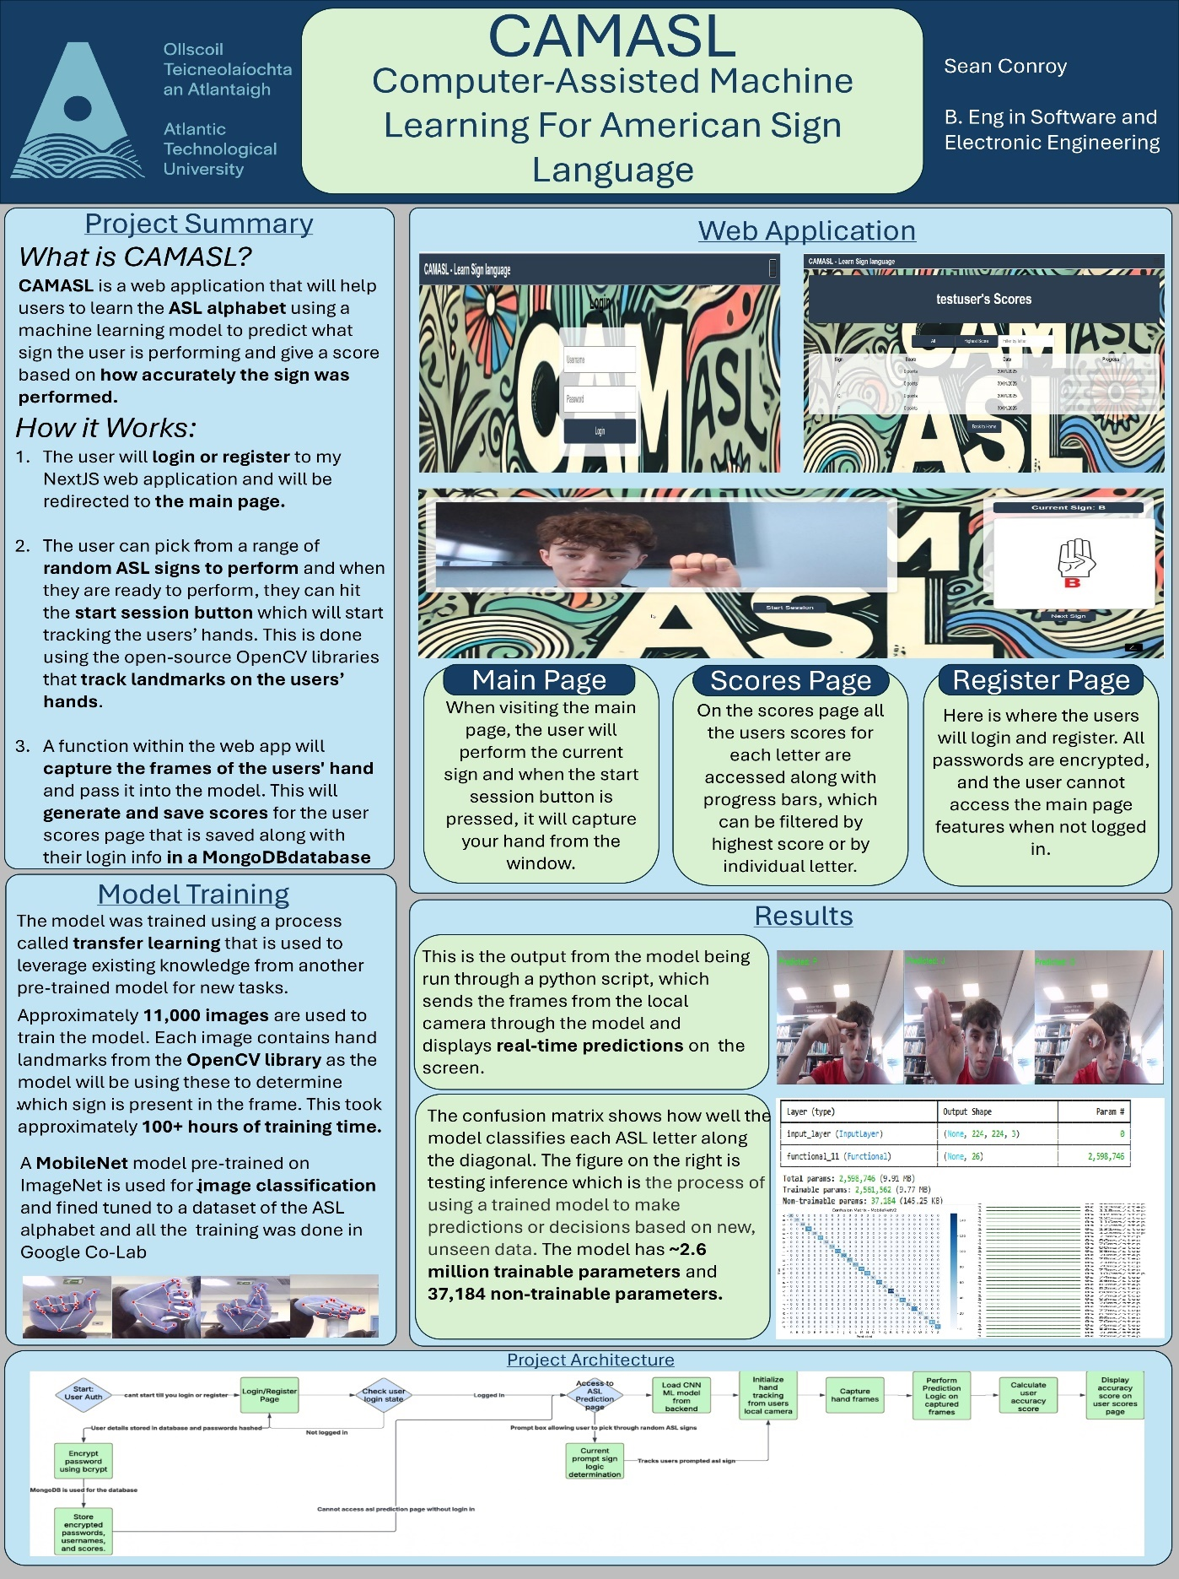

# Introduction

Sign language is a fundamental mode of communication for over **70 million people worldwide**, the majority of whom live in regions with limited access to specialized education and resources [1]. Despite the prevalence and importance of sign language, it remains significantly underutilized globally — spoken by fewer than 2% of the population [2]. As communication challenges continue to affect the Deaf and Hard-of-Hearing communities, promoting broader awareness and understanding of sign language has become increasingly important, particularly in educational and public spaces.

This project, **CAMASL** (Camera-Assisted Machine Learning for American Sign Language), was developed to support this goal by offering an interactive, web-based platform for learning and practicing ASL. The application enables users to perform ASL gestures in front of their webcam and receive immediate, data-driven feedback on their performance. Users are prompted with random signs and can view their accuracy scores in real time, promoting consistent practice and self-assessment. The application is designed to be both accessible and engaging, suitable for absolute beginners as well as more advanced learners who want to test and refine their signing accuracy.

CAMASL is built on a full-stack architecture that combines **machine learning**, **computer vision**, and **web development** technologies. The core of the system is a **MobileNet-based gesture classification model** trained on ASL hand sign data. The model is integrated into a backend API powered by **FastAPI**, which handles image processing, prediction inference, and user authentication. **MediaPipe** is used to detect and extract hand landmarks from webcam input, which are then processed and evaluated by the model. A **MongoDB database** stores user scores and session history, while **React** and **TensorFlow.js** power the frontend, offering a responsive and intuitive user experience directly in the browser.

Motivated by the need for real-time interaction, accessibility, and user-centric feedback, CaMASL integrates performance-focused design decisions such as model optimization, frame-based scoring logic, and session management via secure cookies. The result is a robust and scalable ASL learning tool that blends the best of modern web technologies with applied machine learning to enhance communication and inclusivity.

.

# Background and Technical Foundations

Before building the CAMASL platform, it was essential to understand and evaluate a range of core machine learning concepts to ensure the model would perform well under real-time, user-facing conditions. This section presents the theoretical foundations and practical considerations that informed the model’s development. It includes an exploration of neural networks, with a particular focus on convolutional neural networks (CNNs), activation functions, optimizers, training stability mechanisms like batch normalization, and deployment constraints such as quantization. These components are examined not only in isolation but also in relation to how they influenced the final system architecture and performance of CAMASL.

## Neural Networks and Convolutional Neural Networks (CNNs)

### Overview of Neural Networks (NNs)

Neural networks are the foundation of most deep learning applications. A basic neural network consists of layers of interconnected nodes (neurons), where each connection has an associated weight and bias. Input data passes through these layers where it is transformed via weighted sums and activation functions to learn complex mappings. Traditional feedforward NNs are effective in many domains but struggle with image data, where spatial relationships are important.

### Recurrent Neural Networks (RNNs)

Recurrent Neural Networks are specialized architectures for handling sequential data like text or time series. RNNs have internal loops that allow information to persist, making them ideal for tasks where context from previous steps is important, such as natural language processing or gesture sequences over time. However, RNNs are not optimal for image classification tasks due to their sequential nature and lack of spatial feature extraction.

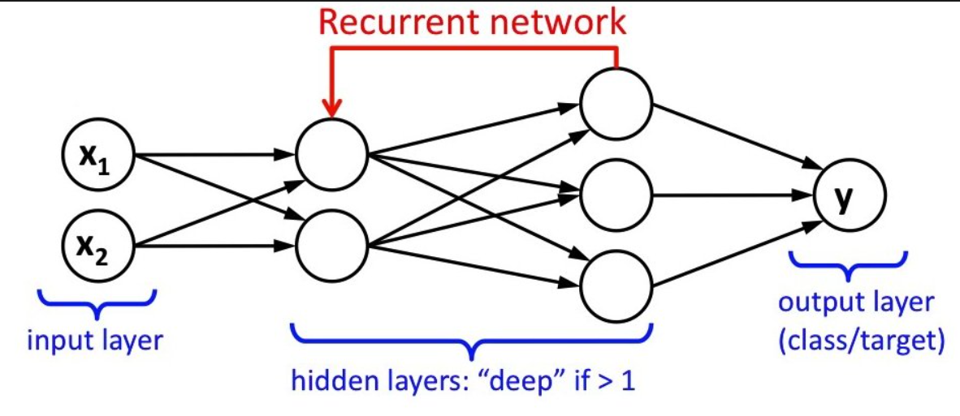

### Why CNNs Were Selected for CAMASL

For CAMASL, spatial feature extraction from image frames was crucial. CNNs outperform both standard NNs and RNNs in image-based tasks due to their use of convolutional filters that detect local patterns. Their ability to preserve spatial hierarchies and reduce parameters via shared weights makes them both efficient and highly performant for gesture recognition from hand images.

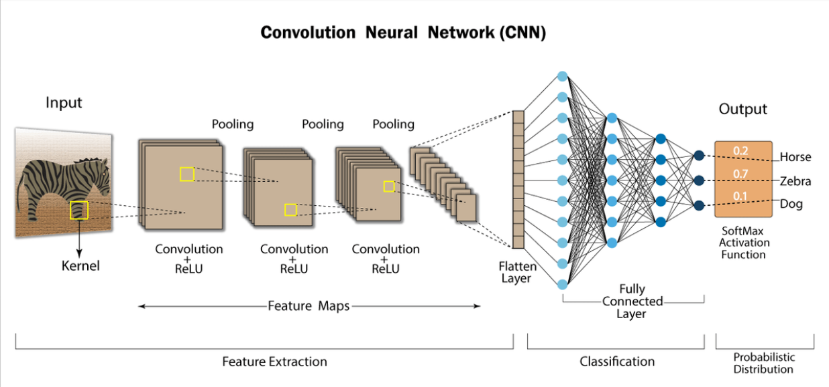

## Activation Functions

### What are Activation Functions

Activation functions are a fundamental component of neural networks, responsible for introducing non-linearity into the model’s computations. In the absence of activation functions, a network composed solely of linear transformations (i.e., matrix multiplications and additions) would not be able to approximate complex, non-linear relationships within the data.

Mathematically, an activation function takes in the weighted sum of inputs to a neuron and determines the output that should be passed to the next layer. It helps the network learn intricate patterns and relationships by enabling the construction of non-linear decision boundaries. Activation functions also influence the flow of gradients during backpropagation, which is vital for training stability and convergence.

Different activation functions have different properties that can affect how fast a model learns, whether it gets stuck during training, or how well it generalizes. Some introduce sparsity, while others prevent saturation or help maintain gradient flow. Choosing the right activation function for a given task and architecture is a crucial part of neural network design and played a significant role in CAMASL's model development.

### ReLU

Activation functions play a crucial role in enabling neural networks to learn complex mappings from input to output. They introduce non-linearity into the model, allowing it to approximate non-linear functions. The Rectified Linear Unit (ReLU) is one of the most widely used activation functions in CNNs due to its computational efficiency and ability to alleviate the vanishing gradient problem. ReLU is defined as f(x) = max (0, x), where all negative values are set to zero, and positive values remain unchanged.

However, ReLU is not without drawbacks. A notable issue is the dying ReLU problem. This occurs when neurons consistently receive negative inputs during training, causing them to output zero and effectively become inactive. Once a neuron dies in this way, it may never recover because the gradient of ReLU is also zero for negative inputs. To address this, alternative activation functions such as Leaky ReLU were explored.

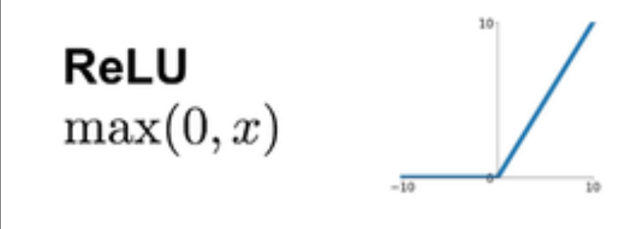

### Leaky ReLU

Leaky ReLU introduces a small negative slope for negative inputs, allowing gradients to flow even when the input is negative. This keeps the neurons active and can improve model robustness. While ReLU was ultimately used in the final model, the behaviour of Leaky ReLU was evaluated during early tests and considered a viable fallback in case training instability emerged.

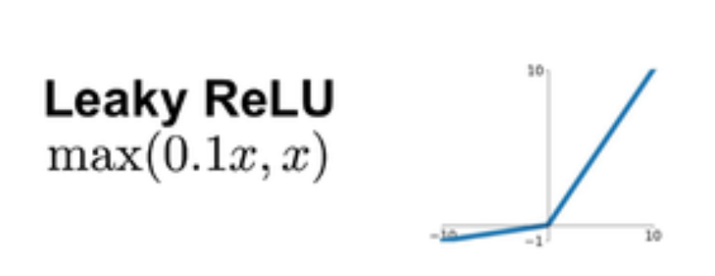

### Sigmoid

Sigmoid squashes input to a [0,1] range, which is suitable for binary classification. However, it suffers from the vanishing gradient problem and was not selected for CAMASL due to slow convergence and lack of gradient flow in deeper layers.

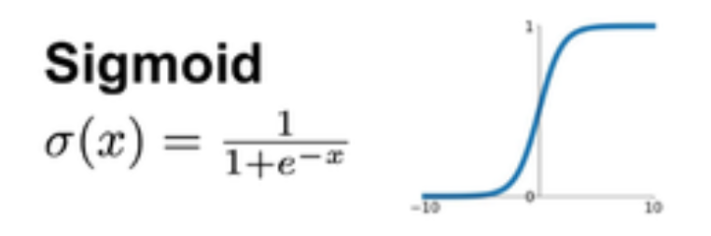

### Tanh

Tanh is similar to sigmoid but outputs values in [-1,1]. Like sigmoid, it suffers from vanishing gradients but centers data better. It was not used in CAMASL as ReLU variants proved faster and more stable for deeper architectures.

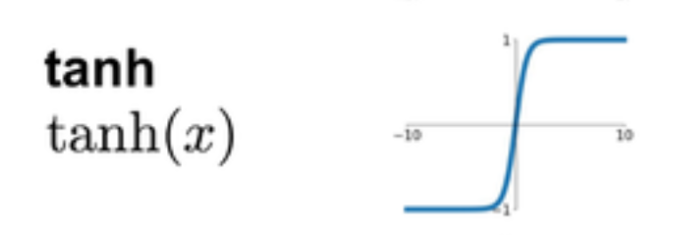

### Softmax

Used in the final output layer of CAMASL’s model. Softmax converts raw output scores into a probability distribution across all 26 ASL classes. The formula is:It ensures that the output values sum to 1 and can be interpreted as class probabilities.

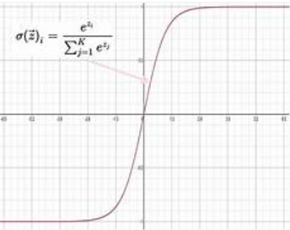

## Optimisers and Learning Dynamics

### What Are Optimizers?

At a low level, an optimizer in a neural network is a mathematical engine that drives how model weights are updated during training. The optimizer aims to minimize a loss function—a measure of how far the model's predictions are from the true labels—by adjusting the weights using gradients computed through backpropagation.

This process works by first calculating the partial derivatives of the loss with respect to each weight (the gradient), which indicates the direction in which the loss increases. The optimizer then applies a rule to adjust each weight in the opposite direction of this gradient, thereby reducing the loss. The magnitude of this adjustment is determined by the learning rate and other internal mechanisms of the optimizer, such as accumulated history of gradients or variance.

Each optimizer—SGD, RMSprop, AdaGrad, AdaDelta, Adam—interprets and scales these gradients differently. These strategies affect how fast the model converges, how well it generalizes, and how stable the training process is.

### Gradient Descent (GD)

Gradient Descent updates weights using the entire dataset to calculate gradients. While it ensures stability, it is computationally expensive and not suitable for large datasets or real-time training.

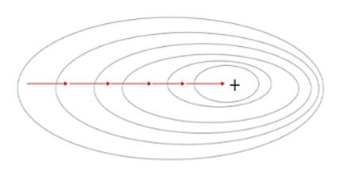

### Stochastic Gradient Descent (SGD)

SGD updates weights per training example, leading to faster, albeit noisier, convergence. It’s simple but may get stuck in local minima without enhancements like momentum.

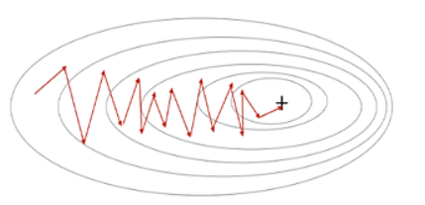

### RMSprop

RMSprop improves on SGD by maintaining a moving average of squared gradients to normalize updates. It’s effective for non-stationary problems and showed consistent performance in early CAMASL tests.

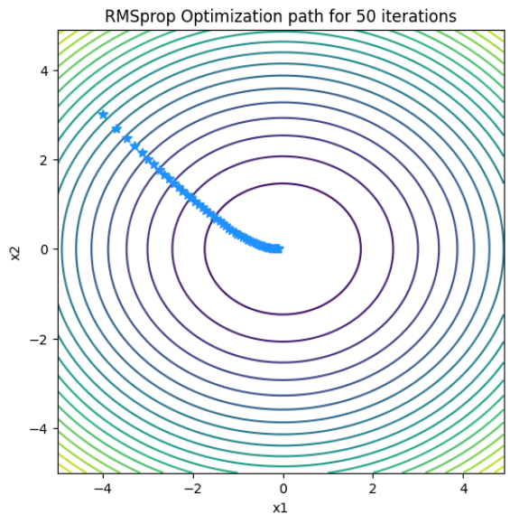

### AdaGrad

AdaGrad adapts the learning rate for each parameter, making it suitable for sparse data. However, it tends to slow down too much due to aggressive learning rate decay and was not ideal for CAMASL.

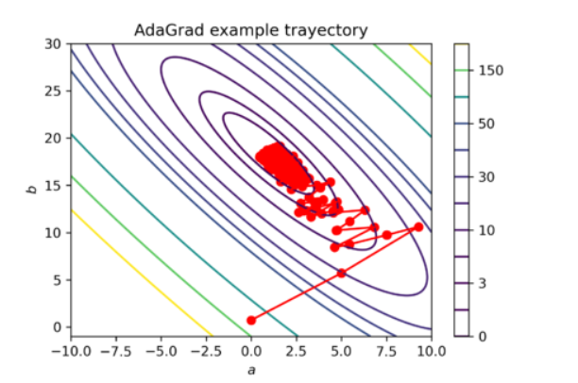

### AdaDelta

An improvement over AdaGrad, AdaDelta dynamically adjusts learning rates without requiring a manually selected learning rate. It performed reasonably well but lacked the convergence speed of Adam.

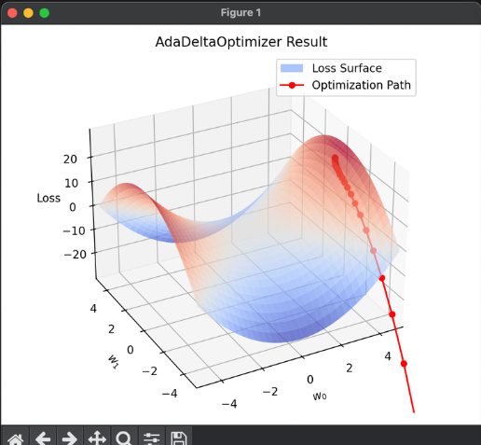

### Adam

Adam combines the advantages of RMSprop and momentum. It adapts learning rates based on the first and second moments of the gradients and uses bias correction. It provided the best convergence, stability, and final accuracy in CAMASL and was selected for the final model.

Optimizers control how a model learns during training by updating weights in response to the computed gradients. Several optimizers were examined for CAMASL, each with distinct characteristics. Stochastic Gradient Descent (SGD) updates model weights using a single sample at a time. While simple and effective, SGD can lead to noisy updates and slow convergence. To improve upon this, momentum-based variants and adaptive learning rate methods were considered.

RMSprop modifies the standard gradient descent algorithm by dividing the learning rate by an exponentially decaying average of squared gradients. This helps normalize the step sizes and is especially effective when dealing with non-stationary objectives. AdaGrad adapts the learning rate for each parameter individually based on the history of gradients, which is advantageous for sparse datasets. However, its aggressive learning rate decay can hinder convergence in later stages of training. AdaDelta extends AdaGrad by using a moving window of gradient accumulation, allowing for dynamic learning rate adjustments without requiring a fixed global learning rate.

Ultimately, the Adam optimizer was chosen for the final training phase. Adam combines the benefits of both momentum (from SGD) and adaptive learning rates (from RMSprop). It keeps track of exponentially decaying averages of past gradients and their squares, then applies bias correction to produce stable and fast convergence. The mathematical formulation of Adam involves computing moving averages of the gradient (first moment) and the squared gradient (second moment), which are then used to scale the learning rate for each parameter. This dynamic adjustment enables Adam to adapt to complex loss landscapes efficiently, making it ideal for CAMASL's varied hand gesture data.

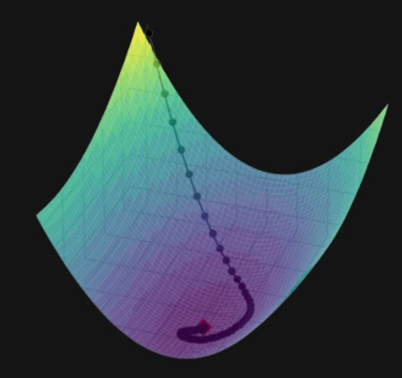

## Batch Normalisation and Training Stability

Batch normalization was introduced into the architecture to improve convergence speed and model stability. This technique normalizes the output of each layer across a mini batch so that they have zero mean and unit variance. This reduces the internal covariate shift — the change in the distribution of layer inputs during training — and enables the use of higher learning rates.

Batch normalization has an additional regularization effect, as it introduces noise during training using batch statistics. This noise can reduce overfitting and increase the model's ability to generalize. In the context of CaMASL, where training samples exhibit variability in lighting, hand position, and gesture angle, batch normalization contributed significantly to maintaining model robustness.

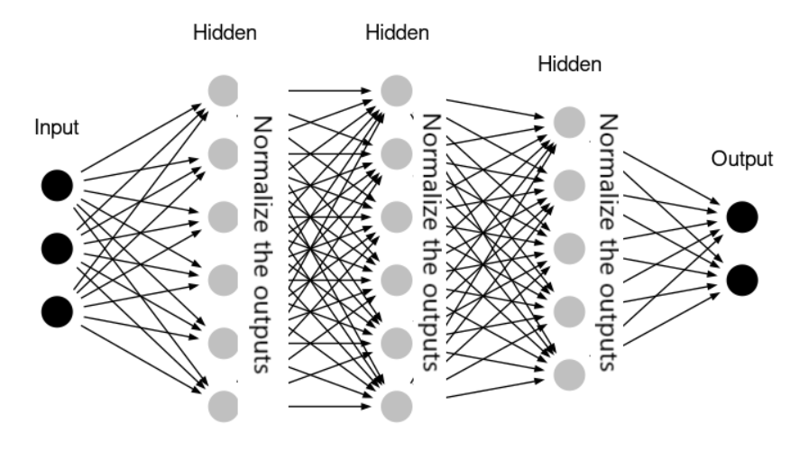

## Quantisation and Deployment Constraints

Quantization is a model compression technique that converts floating-point weights and activations to lower precision formats such as 8-bit integers. This reduces memory usage, speeds up inference, and allows models to be deployed on devices with limited computational resources. Quantization-aware training can be used to maintain accuracy while preparing a model for deployment in resource-constrained environments.

Although quantization was not implemented in the final version of CAMASL due to the decision to shift all model inference to a backend FastAPI server, it was studied as part of the deployment strategy. The idea was initially to load the model client-side using TensorFlow.js, but due to incompatibilities and memory limitations with loading large .bin weight files in the browser, this approach was abandoned. Nonetheless, quantization remains a key area for future development, particularly for enabling true edge deployment of the model on mobile or offline platforms.

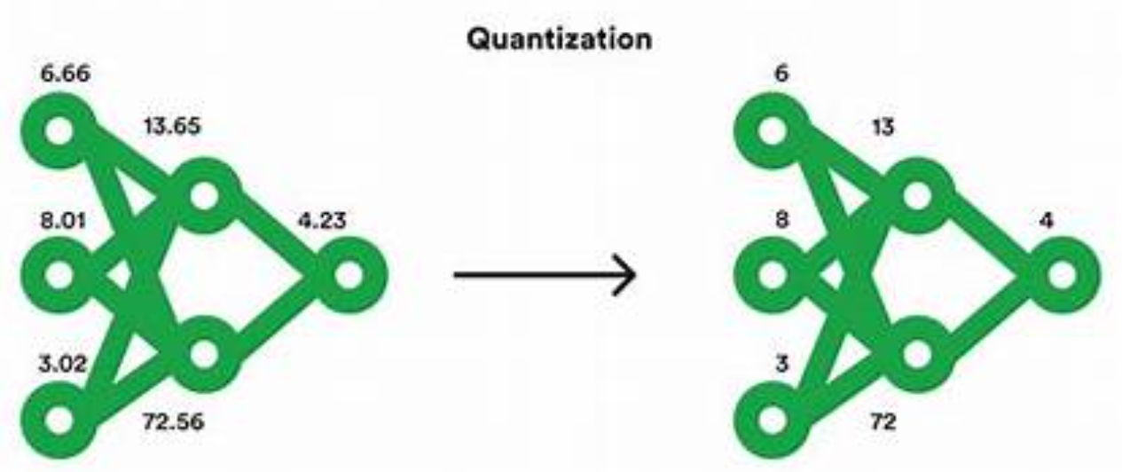

## Integration of CNN’s in CAMASL

The final CNN model used in CAMASL was MobileNetV2, chosen for its architectural efficiency and accuracy. MobileNetV2 introduces inverted residual structures and linear bottlenecks, which preserve representational power while minimizing computational cost. The model was trained on pre-processed ASL gesture data, resized to 112x112 pixels, and augmented using random transformations to increase data diversity.

The model architecture included convolutional layers, batch normalization, ReLU activations, and dense layers leading to a SoftMax output. The training process involved careful selection of batch size, learning rate, optimizer, and early stopping criteria. Validation metrics such as confusion matrices, precision-recall curves, and ROC curves were generated to assess the model’s generalization ability.

Altogether, the design and training of the model reflect a deep consideration of the trade-offs between complexity, speed, and accuracy. The techniques explored during development — from activation tuning to optimizer benchmarking and quantization planning — showcase the underlying theoretical and practical understanding that informed every decision in the project.

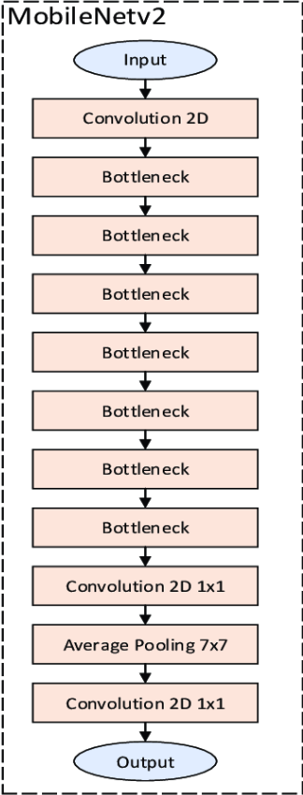 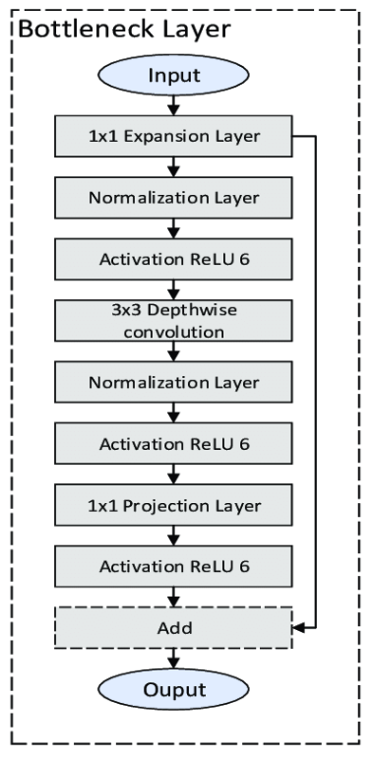

## Real-Time Hand Tracking with MediaPipe

To facilitate real-time gesture detection through the webcam, CAMASL integrates Google's open-source library, MediaPipe. MediaPipe Hands is a framework that provides high-fidelity hand and finger tracking using a pipeline of machine learning models optimized for real-time performance. It consists of palm detection followed by hand landmark estimation.

Palm detection is achieved using a single-shot detector (SSD) model that quickly identifies the region of interest within the image. Once a palm is detected, MediaPipe then refines this region and predicts 21 3D hand landmarks corresponding to key points such as fingertips, knuckles, and joints. These landmarks are calculated in normalized coordinates, allowing robust gesture tracking across various hand sizes and camera angles.

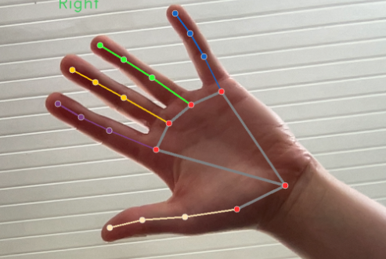

In CAMASL, these landmark coordinates are used to crop the hand region from the video frame before it is resized and passed into the classification model. MediaPipe provides low-latency tracking and supports high frame rates, making it ideal for browser-based or webcam-connected applications. By combining MediaPipe’s landmark extraction with the trained CNN classifier, CAMASL is capable of offering live prediction feedback with minimal delay, contributing to a smooth and interactive learning experience for users practicing ASL.

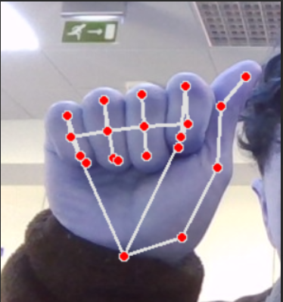

## JavaScript Foundations and Frontend Technologies

While CAMASL’s machine learning backbone was built in Python, the user-facing component of the application required strong knowledge of JavaScript, particularly modern frameworks and libraries such as React. Early in the project, it became clear that delivering an intuitive, real-time experience would demand far more than basic scripting — it required mastering asynchronous programming, browser APIs, and component-based design patterns. This section outlines the key JavaScript concepts I had to learn, the problems I encountered, and the solutions I implemented.

### React and Component-Based Architecture

React is a JavaScript library for building user interfaces based on a declarative, component-based model. Unlike traditional web development workflows that rely on imperative DOM manipulation, React components encapsulate structure, behavior, and styling, and are rendered dynamically based on state changes. In CAMASL, each major feature — such as the login/register form, webcam session view, and scores page — was built as its own component.

Learning how to use **JSX** (JavaScript XML) was a crucial first step. JSX allows you to embed HTML-like code directly within JavaScript, but this came with a learning curve around how expressions, props, and nested components interact. For example, rendering a dynamic sign prompt meant binding random letters from an array into the rendered view using state hooks.

Component reusability was key to minimizing code duplication. For example, I created a generic PromptBox component for showing random signs, and a ScoreCard component that could be reused across user history views. Each of these components was structured to accept props for dynamic content, improving maintainability.

### React Hooks and State Management

To manage interactivity and timing in CAMASL, I relied heavily on **React hooks**, especially:

useState for managing local data like the current sign prompt or captured scores.

useEffect for triggering actions like fetching new prompts or initializing the webcam when the component mounted.

useRef to directly access DOM elements such as the webcam feed or canvas for capturing snapshots.

For example, the timer logic was implemented using useEffect, with an interval that captured webcam frames every 100ms. When the session timer expired (after 30 frames), the state was reset to begin scoring a new gesture. Managing this flow involved precise control over how state and side effects interacted, which I learned to structure carefully to avoid unnecessary rerenders or logic errors.

### Asynchronous JavaScript and API Communication

A major part of the project involved sending data between the React frontend and the FastAPI backend. Each captured image frame needed to be sent via a **POST request** to an API route for classification. This required knowledge of **asynchronous JavaScript** using async/await along with the native fetch API.

Here’s an outline of the asynchronous flow:

1. Capture the image using react-webcam.
2. Convert the image to a base64 string.
3. Send it to the backend using:
4. 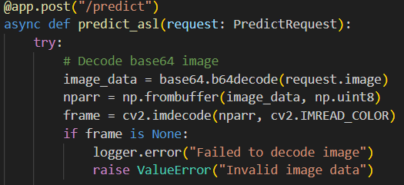
5. Await the prediction result and update the UI accordingly.

Error handling and loading states were important here. I implemented try/catch blocks to catch server errors and conditionally rendered messages when the backend was unavailable or returned an error. This was particularly necessary for debugging model loading and ensuring smooth communication.

### Webcam Integration with react-webcam

Capturing video data from a user’s camera is non-trivial due to browser security requirements and real-time performance demands. I used the **react-webcam** package to simplify this process. It provides a React component abstraction around the browser’s native MediaDevices API.

The webcam component was controlled using a ref, which allowed the app to capture a still image programmatically using .getScreenshot():

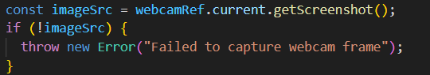

I configured webcam behavior using videoConstraints to ensure high resolution and consistent front-facing camera access, especially on mobile devices:

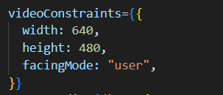

I also handled events such as onUserMedia to detect when the webcam was ready, and onUserMediaError to inform users if permissions were denied.

### Handling Cookies and Secure Session State

Managing user authentication required storing login state securely across sessions. While localStorage is often used for this in simple apps, I chose to implement session tracking using **HTTP-only cookies**, which offer greater protection against client-side attacks like cross-site scripting (XSS).

Upon login, the FastAPI backend generated a **JWT token** and returned it in a cookie:

On the frontend, cookies were accessed using the js-cookie package. Middleware in the backend read and validated the token on every request to protected endpoints. If the cookie was missing or the token expired, the user was redirected to the login page. This strategy ensured that sensitive routes like /scores or /track were only accessible to authenticated users.

### Real-Time Feedback and UI Responsiveness

Because the goal of CAMASL was to provide instant, real-time feedback, UI responsiveness was paramount. I implemented loading indicators and disabled buttons during scoring windows to prevent accidental double submissions or confusion during prediction lag.

React’s reactive rendering made it possible to instantly reflect changes in prediction results, score history, and session state without full page reloads. Combined with CSS modules for scoped styles, this enabled clean, maintainable UI components that worked across screen sizes and input devices.

# Project Architecture

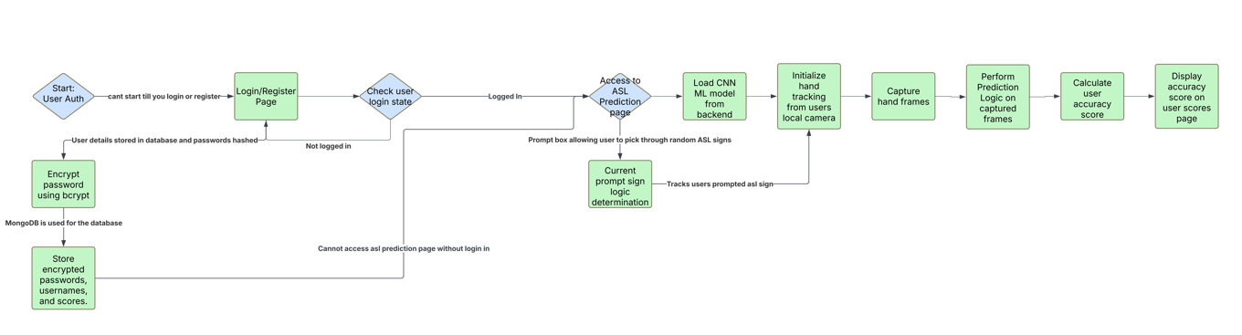

Figure 5‑1 Architecture Diagram

# Project Plan

Throughout the development of CaMASL, Agile methodologies were applied using a sprint-based approach to organize work and track progress. The project was divided into a series of two-week sprints, tracked and managed using Jira. While no formal Gantt chart or Waterfall plan was created at the outset, the iterative nature of sprint-based planning allowed for continuous adaptation and reprioritization based on outcomes, blockers, and testing feedback.

In the early sprints, the focus was on researching sign language datasets, model architectures, and optimization strategies. This included tasks such as collecting and preprocessing data, evaluating models like ResNet50 and InceptionV3, and comparing them to MobileNetV2. Each experiment was logged with metrics, visualizations, and insights into training speed, accuracy, and inference performance. These activities culminated in selecting MobileNetV2 as the final model due to its favorable trade-off between speed and accuracy.

Subsequent sprints focused on integrating the machine learning model with a backend system using FastAPI. This involved building an image classification endpoint that accepts base64-encoded webcam frames, decodes them, extracts landmarks using MediaPipe, and feeds them into the model. The backend then returns a prediction, which is displayed live in the frontend. Several issues related to model conversion and TensorFlow.js were resolved during this phase by choosing a server-side deployment path.

Additional sprints focused on frontend development using React, where key components such as login/register pages, score tracking pages, and webcam interaction logic were implemented. A scoring algorithm was created based on a confidence threshold over 30 frames, ensuring robustness in prediction and accuracy logging. The final sprints were focused on real-time performance tuning, session handling using cookies, route protection, and UI/UX polish.

While not planned upfront with formal documentation, the iterative development and detailed sprint logs ensured comprehensive planning, execution, and reflection over time, ultimately delivering a functional, full-stack, real-time ASL learning platform.

# Project Features and Technical Implementation

This section outlines the core features of CAMASL, their underlying technical implementation, and the rationale behind design decisions. Each feature was developed to enhance usability, performance, or the educational value of the application. The following subsections explore each feature in detail.

## Real-Time Hand Tracking and ASL Prediction

At the heart of CaMASL is the real-time hand tracking and sign classification feature. This pipeline begins on the frontend using the react-webcam library, which accesses the user's local webcam and streams live video frames into the browser. Each frame is captured at regular intervals, encoded as a base64 image, and sent to the backend.

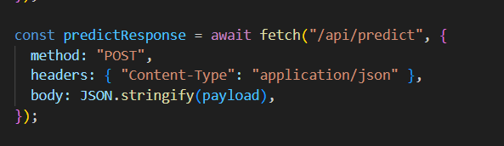

On the backend, FastAPI receives the base64 image via a POST request and decodes it into a usable format using OpenCV. MediaPipe Hands is then applied to the decoded frame to detect the hand and extract 21 landmark coordinates. These landmarks are used to crop and isolate the hand region from the image before resizing it to the dimensions required by the CNN model (112x112 pixels). The cropped image is normalized and passed through the MobileNetV2 model, which outputs a probability distribution over all ASL classes. The class with the highest probability is selected, and its associated confidence score is sent back to the frontend.

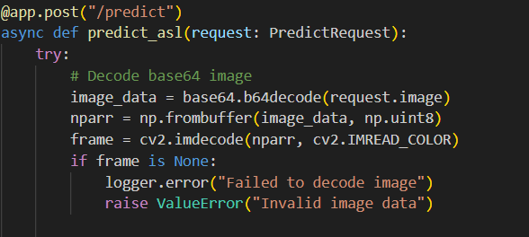

## Scoring Logic and Performance Tracking

To determine the accuracy of a user's gesture, a confidence-based scoring system was implemented. The system maintains a sliding window of 30 frames. If the model returns a consistent prediction above a defined confidence threshold over a sufficient number of frames within this window, a "correct" score is recorded. This approach helps mitigate the effects of brief misclassifications or unstable gestures that occur as the user transitions between signs.

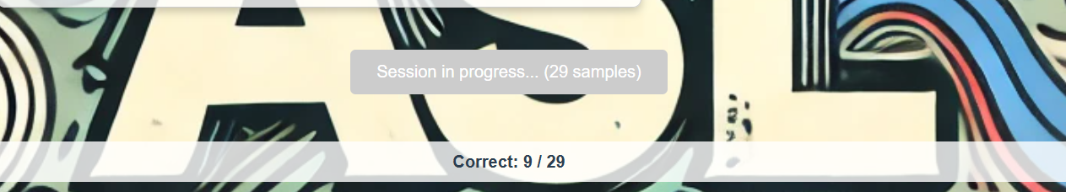

User scores are tracked per letter and updated in real time on the frontend. These scores, including historical performance and high scores per letter, are stored in MongoDB. This allows the user to reflect on their progress and target specific letters for improvement.

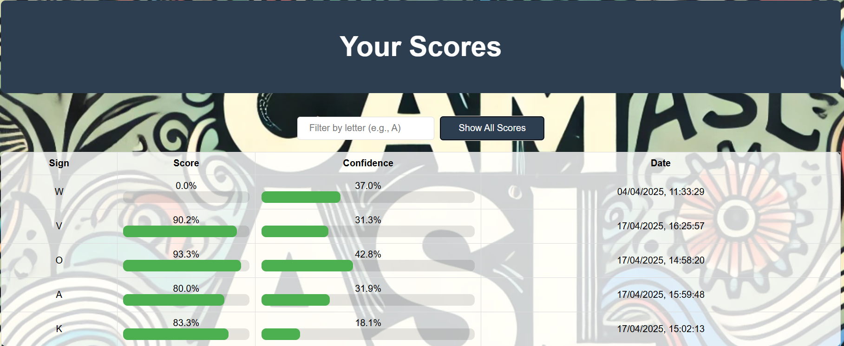

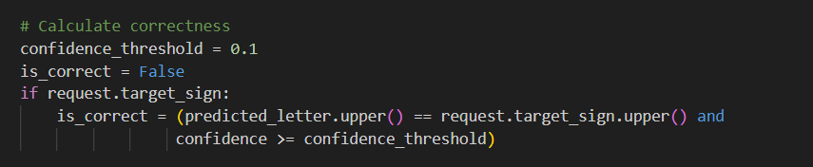

## Authentication and Session Management

Authentication is implemented using JSON Web Tokens (JWT), which are securely stored in HTTP-only cookies to prevent unauthorized access via client-side scripts. When a user logs in, the FastAPI backend validates their credentials and generates a signed token. This token is automatically included in future requests to protected routes.

To verify access, a middleware function reads the JWT from the cookie, decodes it using a shared secret key, and confirms that the user is authenticated. This mechanism ensures that only

logged-in users can access the core features of the application, such as initiating a hand tracking session or reviewing their score history. Logout functionality clears the cookie, revoking access.

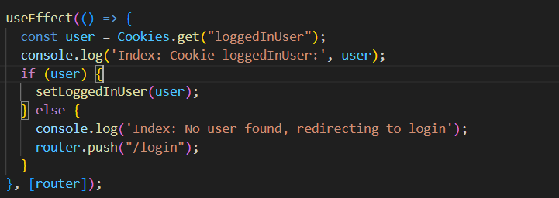

## User Interface and Navigation

The frontend of CAMASL is implemented using React, which enables a modular and reactive user interface. The application includes several key screens: home, login, register, scores, and the main sign recognition interface. These pages are accessible via a banner navigation bar and a collapsible hamburger menu designed for responsiveness and mobile friendliness.

The scores page includes a filterable leaderboard view, enabling users to sort or search their performance by letter. Routing is protected based on authentication status, and users attempting to access restricted pages without a valid token are redirected appropriately.

CSS modules are used for styling to prevent global class conflicts and to ensure that each component’s styles are scoped locally. This enables consistent UI behaviour and prevents unintended overrides.

## Model Integration and Backend Efficiency

Model inference is handled entirely on the server side, avoiding the need to load TensorFlow.js or large model weights in the browser. This decision came after encountering compatibility and performance issues with TensorFlow.js, particularly due to the large .bin weight files and batch shape formatting inconsistencies.

The server uses TensorFlow to load the trained MobileNetV2 model at startup. Since the model remains in memory throughout the session, inference requests can be handled rapidly. The use of FastAPI, which supports asynchronous request handling, ensures that the server remains responsive even when multiple prediction requests are being processed concurrently.

By separating the inference process from the UI thread, the system avoids blocking behaviour that could result in browser lag or UI freezes. Additionally, sending only cropped hand regions to the model significantly reduces the size of each request, minimizing latency.

## Code Snippet and Functional Description

To better understand how the model prediction is integrated, consider the backend route that handles image input and returns the classification result. The relevant FastAPI route is structured to decode an incoming base64 image, process it using OpenCV, detect the hand with MediaPipe, crop and normalize the image, and then pass it to the model. Once inference is complete, it responds with the predicted class and confidence score.

While the exact code is not pasted here to maintain brevity, each function is modular: image preprocessing, model loading, and prediction are handled in separate utilities. This separation allows for maintainability and testing, where the model inference logic can be evaluated independently from the web request lifecycle.

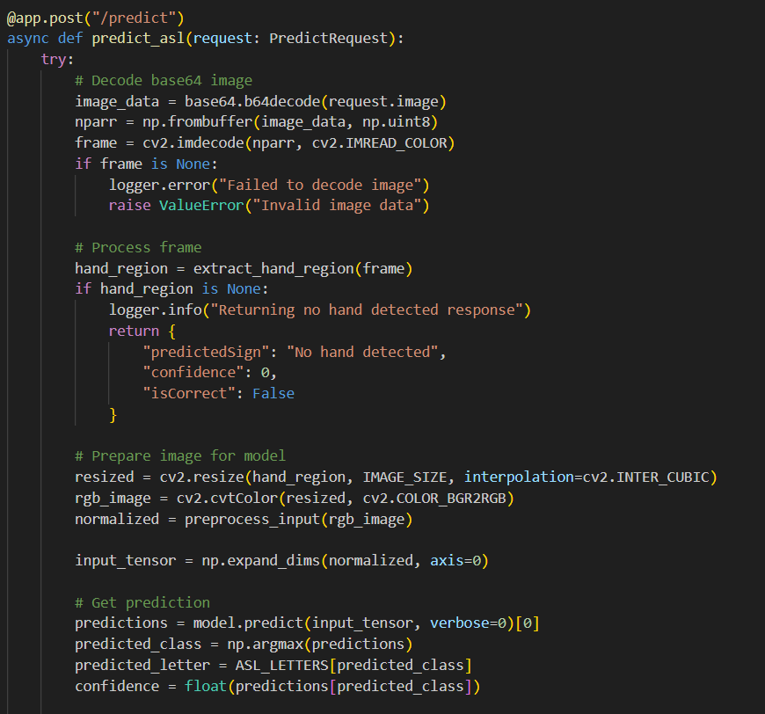

## Scoring Logic and Mathematical Representation

The scoring system is based on a rolling confidence mechanism. Let Ct represent the confidence score at frame t, and T=30 be the total number of frames in a session window. A prediction is considered correct if

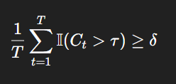

Where:

* τ is the confidence threshold for a single prediction
* δ is the required ratio of confident frames to mark the prediction as correct
* II is the indicator function returning 1 when Ct>τ else 0

This formula ensures predictions that are not heavily swayed by brief misclassifications.

## Major Challenges and Solutions

One major challenge was the transition away from TensorFlow.js. Early attempts to run model inference in the browser using tf.loadGraphModel encountered persistent errors related to JSON structure (e.g., missing batch_input_shape) and memory overload from .bin files. Even after manually adjusting fields like inbound_nodes, the size and complexity made client-side deployment infeasible.

The solution was to move inference server-side using FastAPI and Python's TensorFlow, which allowed better control of memory and compatibility. Another challenge was maintaining performance in real-time prediction. To address latency, only cropped hand regions are sent to the model, and FastAPI’s async capabilities ensure that multiple predictions don’t block other requests.

Cookie-based JWT session handling was implemented to provide secure, persistent login sessions, replacing an earlier approach using localStorage that was vulnerable to client-side attacks. Middleware was developed to check JWTs on sensitive routes, ensuring protection across all application layers.

## Random Sign Prompt System

The random sign prompt feature in CAMASL serves as the starting point for user interaction during practice sessions. It ensures that users are presented with a randomized ASL letter from the alphabet, which they must then attempt to replicate using their hand in front of the webcam. This functionality is implemented in the React frontend using a simple array of ASL letters and a random selection function.

The core logic is triggered by a user clicking the "Start Session" button, which calls this function

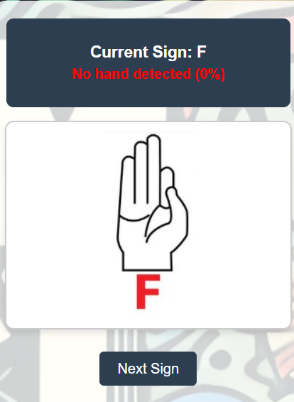

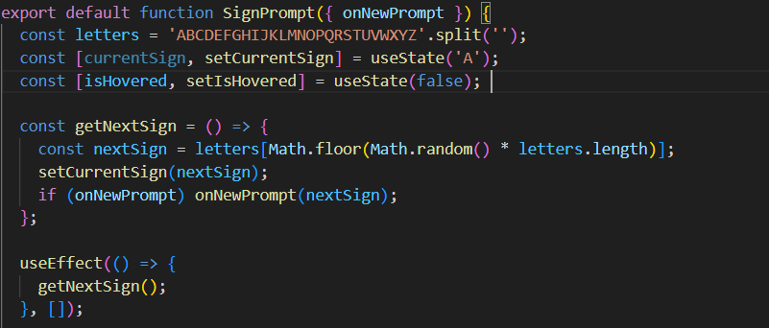

Once a letter is selected, it is stored in React state using the useState hook. The selected sign is then displayed in the prompt box on the UI, allowing the user to focus on replicating that specific gesture. The component is re-rendered whenever the sign changes.

When the timer reaches zero or the scoring window ends, this function is called again to fetch a new sign. This looping process provides an engaging and continuously varied practice experience.

## Timer and Frame Window Control

The prediction and scoring process in CAMASL is time-bound. The user has a limited window typically 30 frames to perform the gesture. This is coordinated using a timer-based system that triggers frame captures and manages when predictions should be evaluated.The logic uses JavaScript's setInterval function or the useEffect hook combined with time-based state.

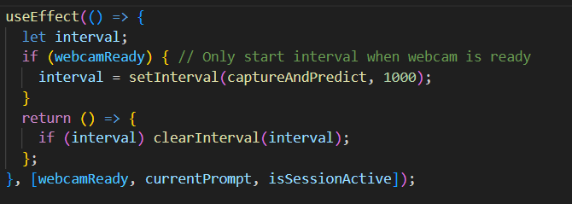

Each frame's prediction and confidence score are recorded in an array. When the array reaches 30 frames, the system calculates the number of frames where the confidence score exceeds the correct threshold (see Section 6.7 for equation). If the threshold is passed, the sign is considered correctly performed.

The timer resets after each scoring window, and a new prompt is presented. This rhythm ensures fair and consistent evaluations and gives users just enough time to react and position their hands.

## Score Persistence and Leaderboard Logic

A critical part of the learning experience in CAMASL is the ability for users to track and reflect on their performance over time. Every correct prediction, along with the associated confidence score and letter, is saved to a MongoDB Atlas collection under that user’s profile.

The data schema for scores includes the username, letter attempted, final confidence score, and timestamp. These records are submitted via a POST request to the FastAPI backend after each session, where they are stored securely. The scores can then be queried and retrieved through GET requests to populate the user’s score history.

In the frontend, the scores page features a filterable table or card layout. Users can sort their scores by ASL letter, search for a specific entry, or view their highest score per letter. This encourages targeted practice and improvement, while also providing transparency into how the scoring algorithm perceives each gesture.

Example route in scores for posting a score:

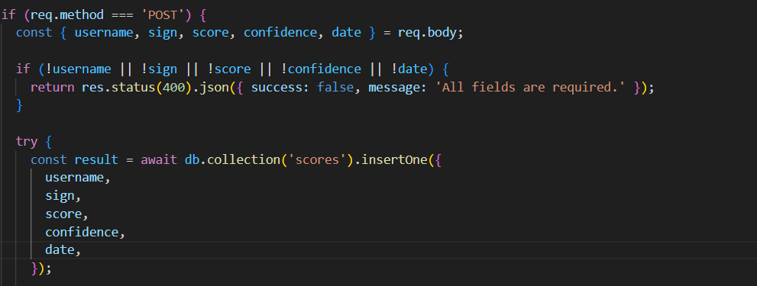

## Camera Component and Frame Capture Logic

The webcam feed is handled by the react-webcam library, which abstracts camera access into a React component. A reference to the webcam is created using useRef(), which is then used to programmatically capture frames. This design allows the app to control exactly when a frame should be captured — for instance, once every 100 milliseconds during a scoring session.

Example implementation:

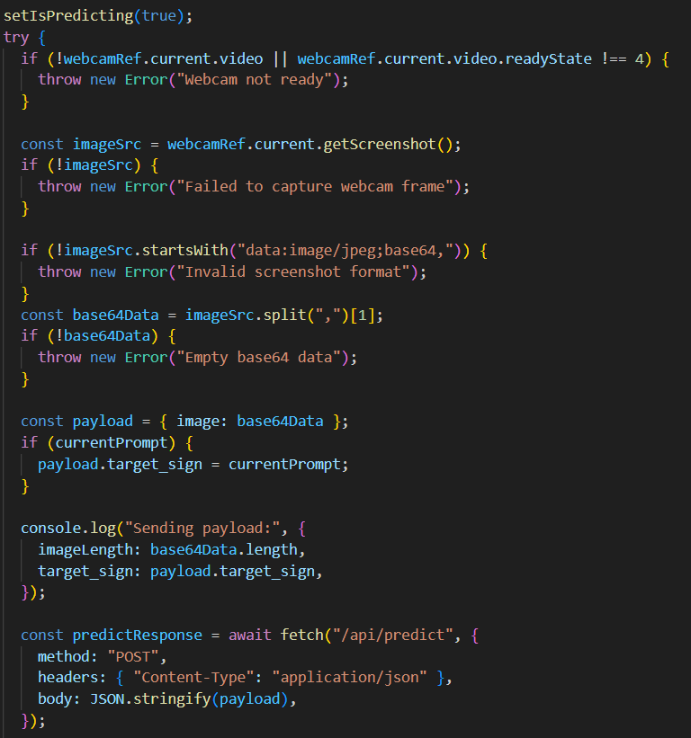



Video constraints such as resolution and facing mode are configured through props, ensuring compatibility across devices. The webcam component is also configured to trigger certain callbacks like onUserMedia and onUserMediaError, which signal readiness and handle permissions issues respectively.

This modular and event-driven design ensures high responsiveness and a reliable video capture pipeline.

## Additional Features and Opportunities for Expansion

While the core features of CaMASL provide a strong foundation for ASL practice, several additional ideas were considered or partially implemented. These include:**Milestone Goal Tracking**: Users could define accuracy goals or streaks and receive notifications when they reach certain benchmarks.**Gesture Correction Feedback**: Advanced models could be used to highlight common misclassifications and guide users with visual feedback (e.g., "try spreading fingers more").**Multi-Hand Recognition**: Future versions could handle two-hand gestures by extending the MediaPipe pipeline and supporting more complex classification tasks.**Offline Practice Mode**: While current inference is server-based, future iterations could integrate lightweight models via ONNX or TFLite for offline support.

# Model Evaluation and Performance Metrics

A critical part of developing CAMASL was ensuring that the gesture recognition model could generalize well to unseen hand signs and perform consistently in real-time conditions. To validate its effectiveness, the final MobileNetV2 model was evaluated using multiple performance metrics on a held-out test dataset.

## Accuracy, Precision, Recall, and F1-Score

These metrics were computed across all classes (A–Z) to provide a comprehensive view of model performance:

* **Accuracy** measures the proportion of total predictions that were correct.
* **Precision** reflects the proportion of true positive predictions over all positive predictions, indicating how reliable each gesture prediction is.
* **Recall** measures the ability of the model to identify all instances of each gesture.
* **F1-Score** provides a harmonic mean of precision and recall, balancing both metrics for cases where class imbalance is present.

These scores indicated high performance on the test set, with F1-scores close to or above 0.95 in most cases.

## Confusion Matrix

To visualize misclassifications, confusion matrices were generated for the test set. Each axis of the matrix represented the actual and predicted labels, allowing for quick identification of problem areas.

The resulting matrix was largely diagonal, indicating strong performance. The most frequent misclassifications occurred between signs with similar visual shapes, such as **'L' and 'V'** — an expected outcome given the similarity in hand positioning.

## ROC Curves and AUC

Receiver Operating Characteristic (ROC) curves were plotted for each class, illustrating the trade-off between true positive rate (TPR) and false positive rate (FPR). The Area Under the Curve (AUC) was computed as a scalar performance summary.

For most classes, AUC scores were close to 1.0, demonstrating the model's strong ability to distinguish each letter from all others — a critical capability for a real-time classifier handling multiclass predictions.

## Manual Verification

In addition to metrics on the static test set, qualitative validation was carried out by manually performing signs in front of the webcam. Predictions were monitored in real time through browser console logs and on-screen feedback.

This hands-on testing verified that:

* The model could maintain high prediction confidence when the user performed a gesture clearly.
* Frame-to-frame fluctuations were minimal under consistent lighting and positioning.

This combination of statistical and real-time validation provided strong confidence in the model’s robustness and usability for live gesture classification.

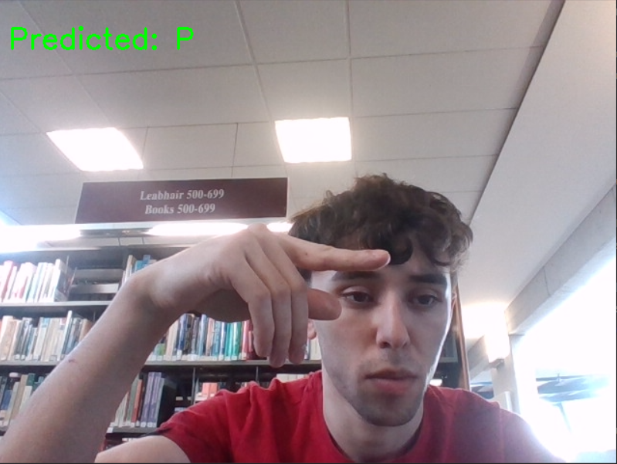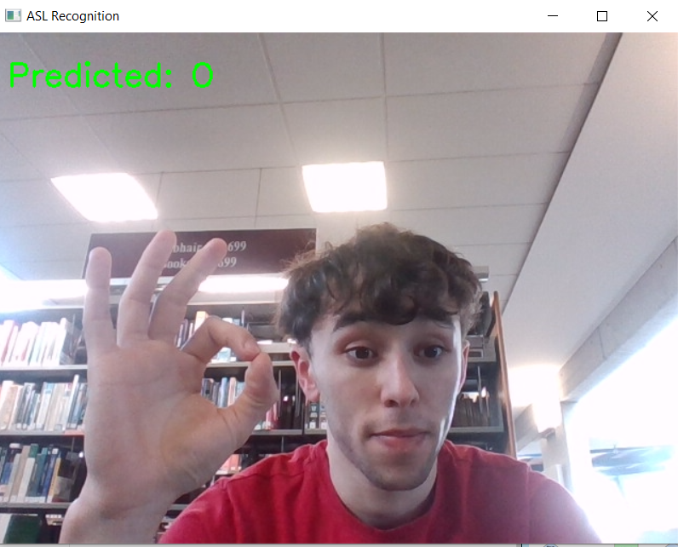

# Ethics

The development of CaMASL required careful consideration of ethical issues related to accessibility, data privacy, and responsible use of machine learning technologies.

A primary ethical motivation behind the project was improving accessibility for users in the Deaf and Hard-of-Hearing communities. By enabling ASL practice through a freely available web application, CaMASL promotes inclusivity and lowers the barrier to entry for learning sign language. Accessibility was a guiding principle in design, ensuring that the UI was intuitive and usable across various devices and screen sizes.

Data privacy was treated as a core responsibility. All user data, including login credentials and performance metrics, is stored securely in a MongoDB database and is only accessible via authenticated API routes. Session handling uses HTTP-only cookies to minimize the risk of client-side attacks such as cross-site scripting (XSS). No video or image data is permanently stored; instead, images are processed in real time and discarded after prediction, ensuring user privacy is maintained.

In terms of machine learning ethics, the model is used solely for educational and feedback purposes, not for identity recognition or surveillance. Users are informed about how their input is processed, and no biometric data is retained. The project does not attempt to interpret full ASL sentences or language structure, which could raise risks of misinterpretation or misuse in critical contexts. By focusing only on individual alphabet gestures and offering real-time feedback in a safe, user-controlled environment, the application avoids overstating its capabilities.

Future versions of the platform may explore further ethical features, such as customizable confidence thresholds for users with varying motor control, and a code of conduct or terms of use to protect the platform’s purpose as an educational tool.

# Conclusion

The CAMASL project successfully achieved its objective of creating a real-time, interactive sign language learning platform powered by modern machine learning and web technologies. Through a series of informed design decisions, the application has evolved into a stable and accessible tool capable of offering ASL gesture recognition with real-time scoring and progress tracking.

The core of the system is built on MobileNetV2—a lightweight yet accurate convolutional neural network model—trained and evaluated with detailed attention to architecture, activation functions, optimizers, and inference requirements. MediaPipe's integration ensured that high-fidelity hand landmarks could be extracted and passed into the model efficiently, and FastAPI handled backend inference smoothly. Frontend components were crafted in React, ensuring an engaging and responsive user experience.

Major hurdles, including model format compatibility, real-time processing constraints, and client-server communication, were successfully overcome. Ethical practices around data handling, accessibility, and transparent AI usage were central to the project's development and final deployment.

CAMASL represents a significant step toward accessible ASL learning and lays the groundwork for future expansion, such as multi-hand gestures, sentence-level interpretation, and offline capabilities via ONNX or TFLite. The final product is not only a working prototype but a robust framework for future educational innovation.

.

# Appendix

# References

|  |  |
| --- | --- |
| [1] | H. Kinsley, "Reinforcement Learning," PythonProgramming, [Online]. Available: https://pythonprogramming.net/q-learning-reinforcement-learning-python-tutorial/. [Accessed 02 02 2021]. |
| [2] | [Online]. |
| [3] | MakeSigns, "Scientic Posters Tutorial," [Online]. Available: https://www.makesigns.com/tutorials/scientific-poster-parts.aspx. [Accessed 09 02 2021]. |
| [4] | Arduino. [Online]. Available: https://www.arduino.cc/. [Accessed 09 02 2021]. |
|  |  |
|  |  |

[x] J. C. Russ and F. Brent Neal. *The Image Processing Handbook*. 7th ed. Boca Raton FL: CRC Press, 2017.

[x] S. Lippman, J. Lajoie and B.E. Moo. “Classes” in *C++ Primer*. 5th ed. Massachusetts: Addison Wesley, 2013.

[x] IEEE Signal Processing Society. “Signal Processing for 5G”, *YouTube*, 2019. [Online]. Available: <https://www.youtube.com/watch?v=uca6X4Ykcmg&list=PLcZOnmyqlalacL9YqkhyufLQGIW_C78Os&index=6>. Accessed: Feb 2, 2021.

[x] Digilent. “Basys 3 Reference Manual”, *Digilent Reference*. [Online]. Available: <https://reference.digilentinc.com/basys3/refmanual>. Accessed: Feb 2, 2021.

[x] P. J. Ashenden. *Digital Design (Verilog): An Embedded Systems Approach Using Verilog*. Burlington: Morgan Kaufmann, 2007.

[x] M. Lynch. “Discrete Fourier Transform (DFT)”, Lecture, Digital Signal Processing, Galway-Mayo Institute of Technology, Galway, 2020.

[x] MRC Centre for Global infectious Disease Analysis. (2021). *Covid-Sim*. [Source Code]. Available: <https://github.com/mrc-ide/covid-sim>. Accessed: Feb 2, 2021.

[x] OpenCV. “Face Detection Using Haar Cascades”, *OpenCV-Python Tutorials*. [Online]. Available: <https://opencv-python-tutroals.readthedocs.io/en/latest/py_tutorials/py_objdetect/py_face_detection/py_face_detection.html#face-detection>. Accessed: Feb 2, 2021.